For Bindu:

1. Answer (on the lab report):
   1. What OS did you use as your host? Why?

Answer: Windows 10 was chosen as the host OS for its widespread use and compatibility.

* 1. Familiarity with the OS (how long have you been using it)?

Answer: I have been using Windows 10 for 3 years.

* 1. Which hypervisor did you use? Why? What made you choose this one?

Answer: I use VirtualBox d as the hypervisor for its user-friendly interface and features.

* 1. Ensure that each VM has the ability to host 2 network ports and can use USB's as needed. Show me how you you did it.

I configured each VM with 2 network ports and USB support through VirtualBox settings.

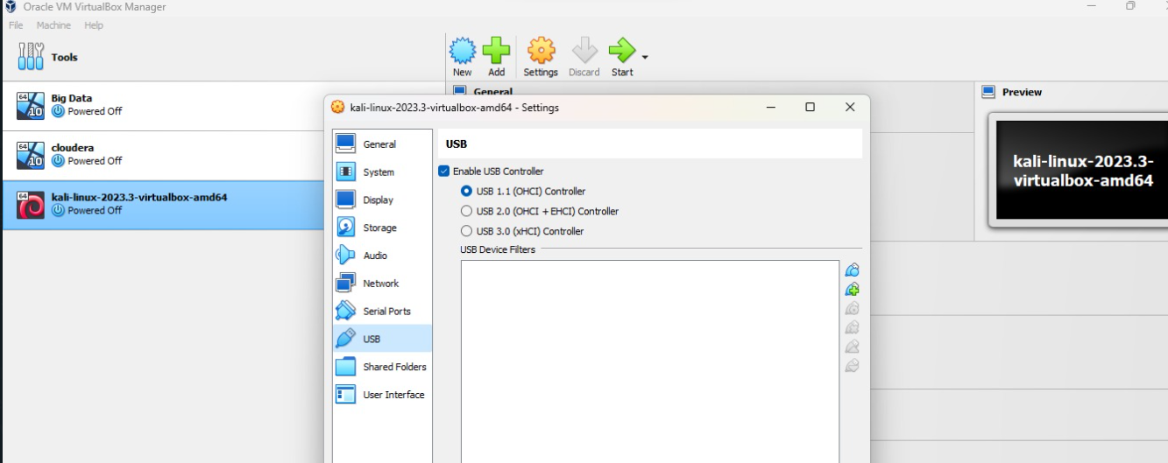

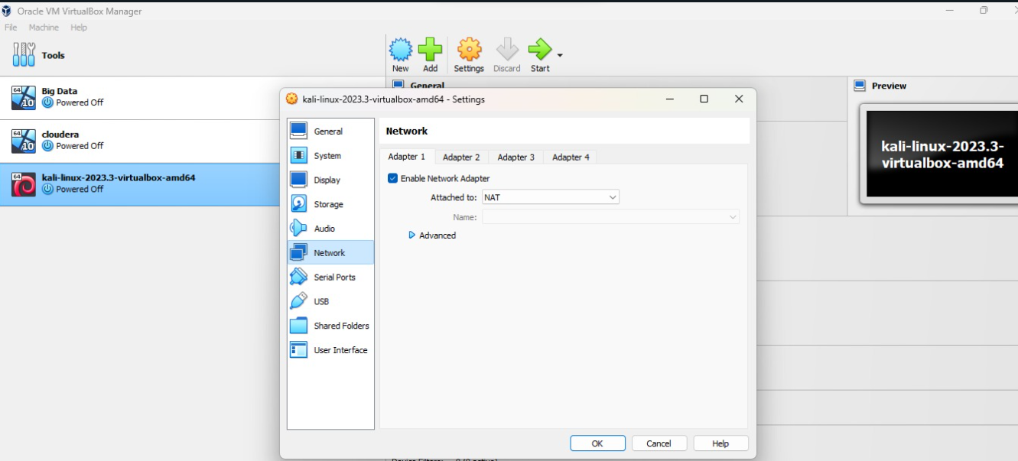

1. What did you find most challenging about the install (did you discover that some machines require that you turn on virtualization in the BIOS, etc)?

I changed the BIOS settings earlier in the process with the help of professor.

1. What would have done differently?

Going through documentation for east setup of the virtual box.

1. What recommendations would you make to someone doing this for the first time?

For first-timers, I recommend thoroughly checking and enabling virtualization in the BIOS before starting the installation process. Keeping note of each step for future reference is important.

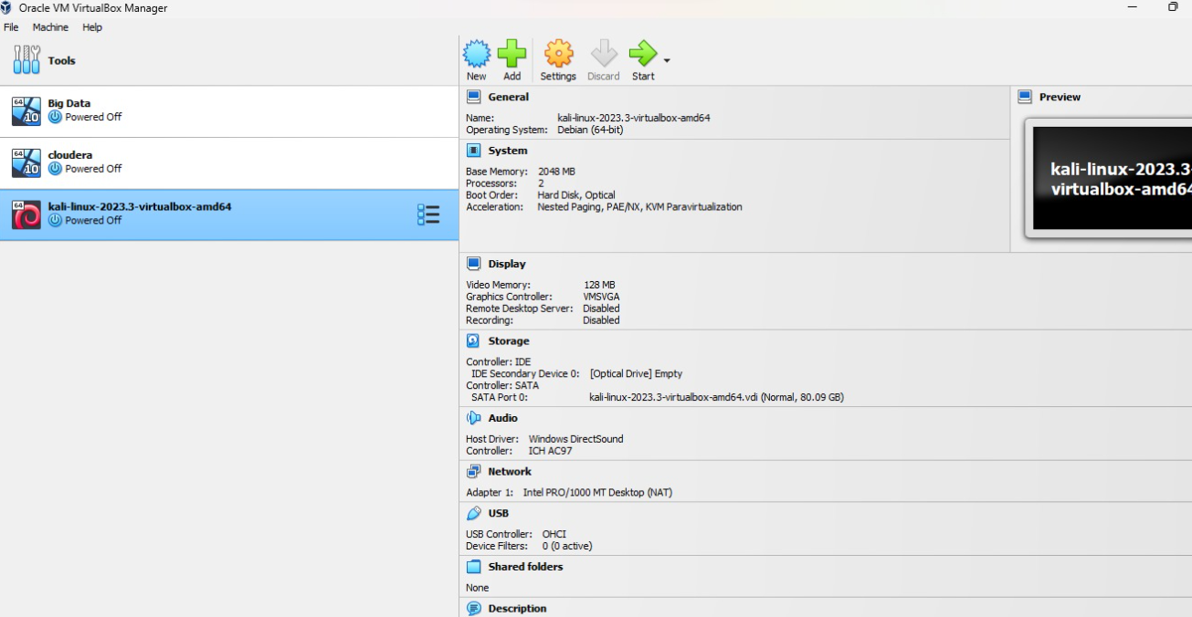

I installed windows 10 and kali in my virtual box.

Friend:

1) A. I used Windows 10 as my host OS for familiarity and compatibility with various software.

B. I've been using Windows 10 for 2 years.

C. I used Virtual Box as my hypervisor for its user-friendly interface and suitability for college labs.

D. I added in the VM, 2 network ports and USB support by configuring the settings in Virtual Box.

2) The most challenging aspect was configuring virtualization in the BIOS for some machines.

3) I would have checked BIOS settings earlier to streamline the installation process.

4) For first-timers, I recommend understanding the different hypervisors like virtual box, VMware. Understanding them gives you ease of use.